NARA File Analyzer and Metadata Harvester

Overview
DESCRIPTION

The NARA File Analyzer Tool walks a directory tree and performs a "File Test" on each file that is encountered. The application framework allows new File Tests to be quickly developed and deployed into the application. The results of each File Test are compiled into a table that summarizes the results of the analysis.

A File Test is a simple set of actions that are performed upon a single file such as filename validation, file size statistical analysis, checksum calculation, file type extraction. Depending on the action, the content of the file may or may not be read. Each File Test is configured with filters that determine which files will be processed by the File Test (i.e. only image files).

Each File Test will generate a table of results. The number of columns and the definition of the columns will vary from test to test. For example, a file type analysis will report the file extension and the number of files discovered with that extension. The checksum file tests will report the name of a file and the checksum string associated with that file.

The File Analyzer tool can be run as a GUI in which the results are displayed in a table. The File Analyzer can also be run in batch mode. In batch mode, the results will be written to a tab-separated file. The GUI version of the application allows the results of multiple executions to be merged. The merged information can be filtered to display matching values and mismatched values.

BENEFITS

The NARA File Analyzer automates a number of simple tasks that would be tedious to perform either manually or with other COTS applications.

The match/merge capabilities have provided a very powerful and simple mechanism to ensure quality control checks on large numbers of files.

Note: NARA has also deployed a customized version of this application that performs file tests that implement custom business rules such as file name validation and metadata introspection.

DEPLOYMENT

The basic File Analyzer application is deployed as a self-extracting jar file. The application requires Java SE 1.6 or higher to be present on the user's workstation. The application can be launched by double clicking the jar file.

If additional runtime memory is needed when running the application, a simple windows bat file can be created to launch the application with a larger memory allocation.
java -mx1000m -jar fileAnalyzer.jar

Using the Application
After starting the application, the user will be presented with a screen in which the following information will be requested.
- The input directory to analyze
- The output directory in which to save results (optional)
- The File Test to apply to the input files
- The maximum number of files to process
- Filter criteria for selecting the files to process (the filters that appear depend on the selected File Test)
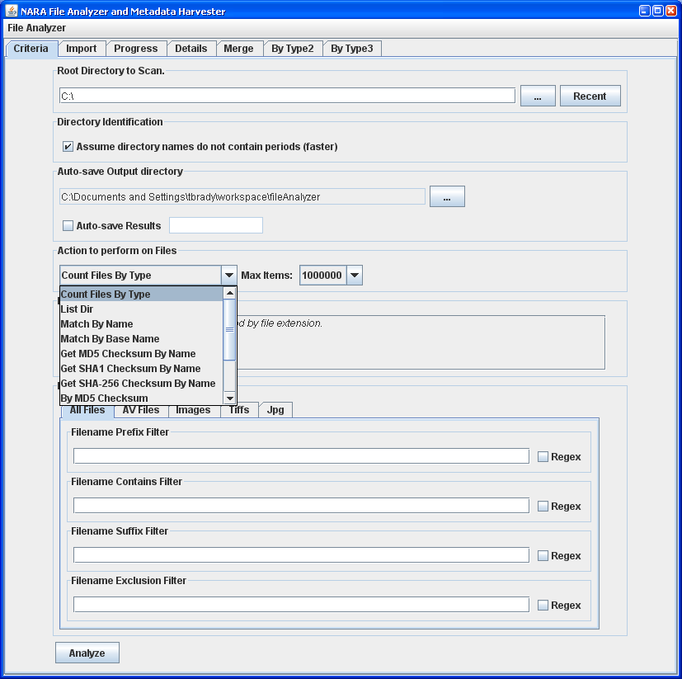

Hit “Analyze” to start the file analysis. The application will switch to the Progress Tab. The progress tab will identify the number of directories to be scanned an the percentage of those directories that have been processed. Depending on the number of files to process, the analysis could take seconds or several hours. A running task can be canceled if needed.
The Progress Tab also provides a summary of the Analyses that have been run during the session. If output is being automatically saved at the conclusion of each analysis, the file name will display.

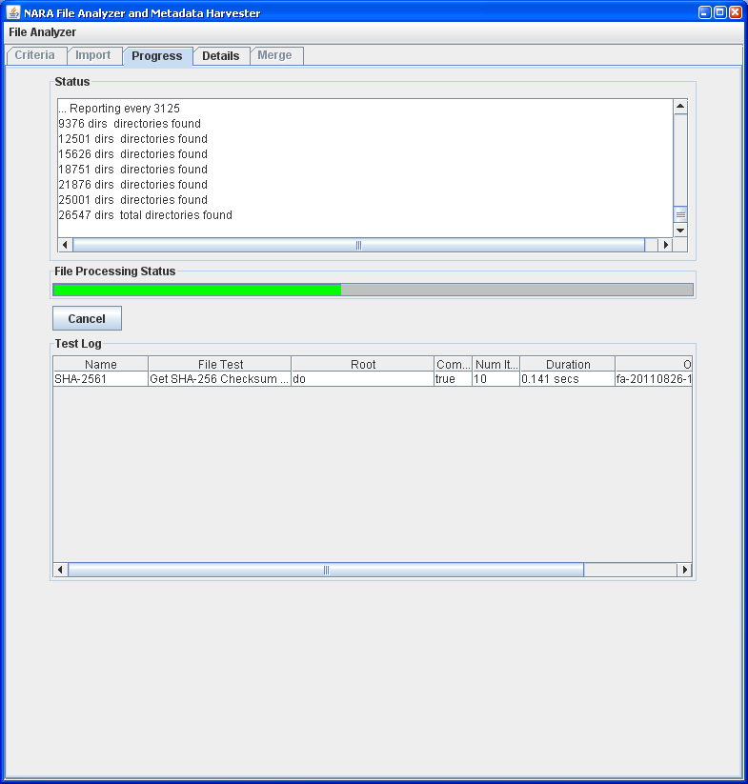
Once an Analysis is complete, the results will open in a new tab. The tab name will usually contain an abbreviation of the name of the File Test that was performed.
The number of columns that display will depend on the File Test that was chosen. Some File Tests define filters that can be applied to the Test results. All columns within the results table are sortable.

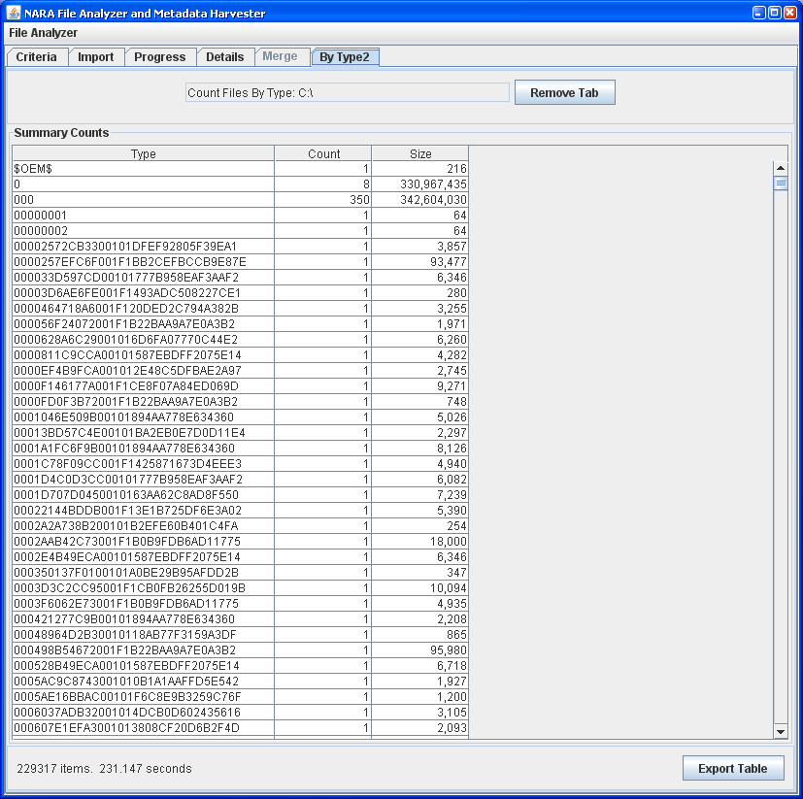
File test results can be exported to a tab-separated file. The user can choose the columns to export. Each File Test will recommend the columns that should/should not be exported.
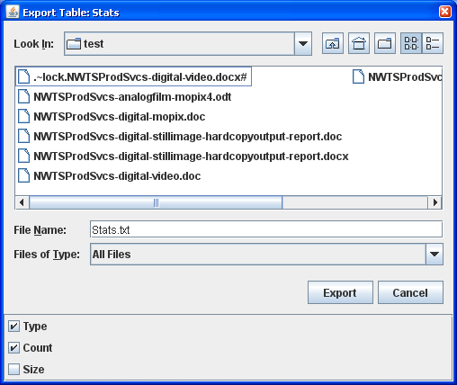

The Details Tab within the application provides a file-by-file summary of the files that were processed. A number of filters are provided to help navigate the information on this tab.
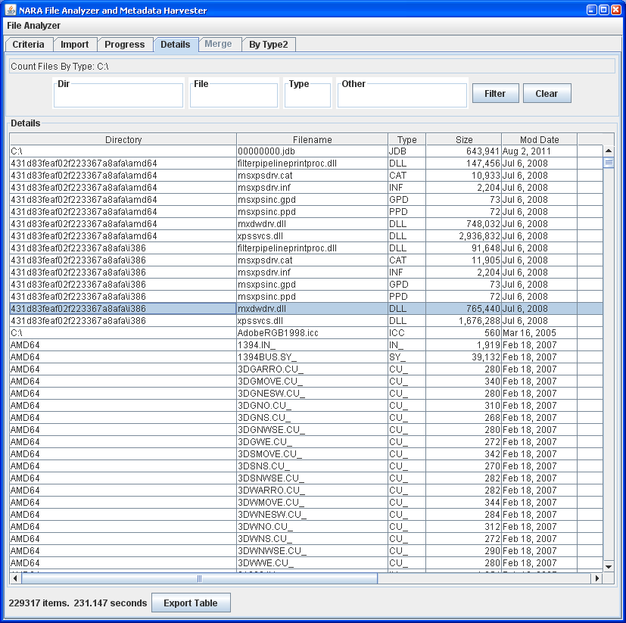
Exported results from prior File Tests can be re-imported into the File Analyzer from the Import Tab. The Import Tab also provides a very simplistic mechanism to auto-generate a sequence of values. This capability can be useful when merging the results from multiple operations.
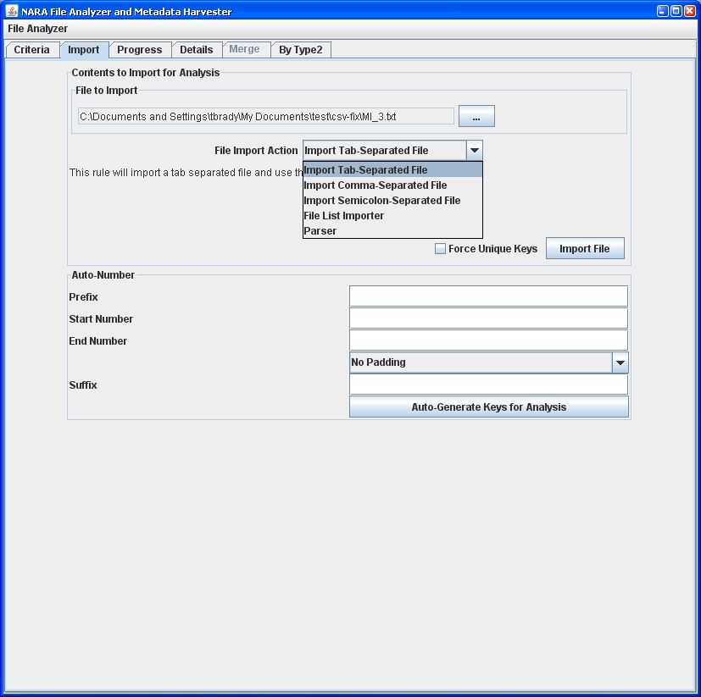

Once 2 or more File Tests or Import operations have been performed, the Merge Tab will become active. This tab will allow the user to configure the results to perform a comparison against. The first column of each results table will be the field that is used to perform a match. The user may select any other column to use when performing the comparison. The user may compare any number of result tables at one time.
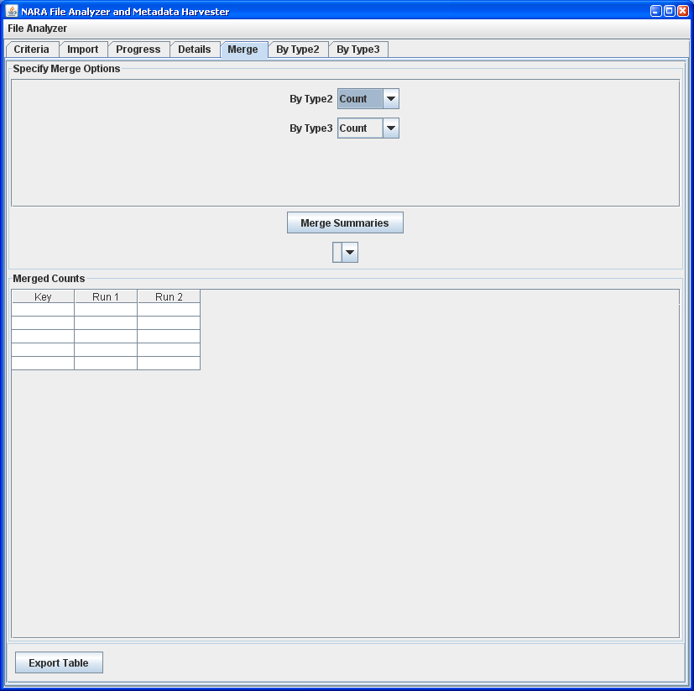
The merge results will display in a table. The user can further filter the display to look only at matching items, mismatched items or missing items.

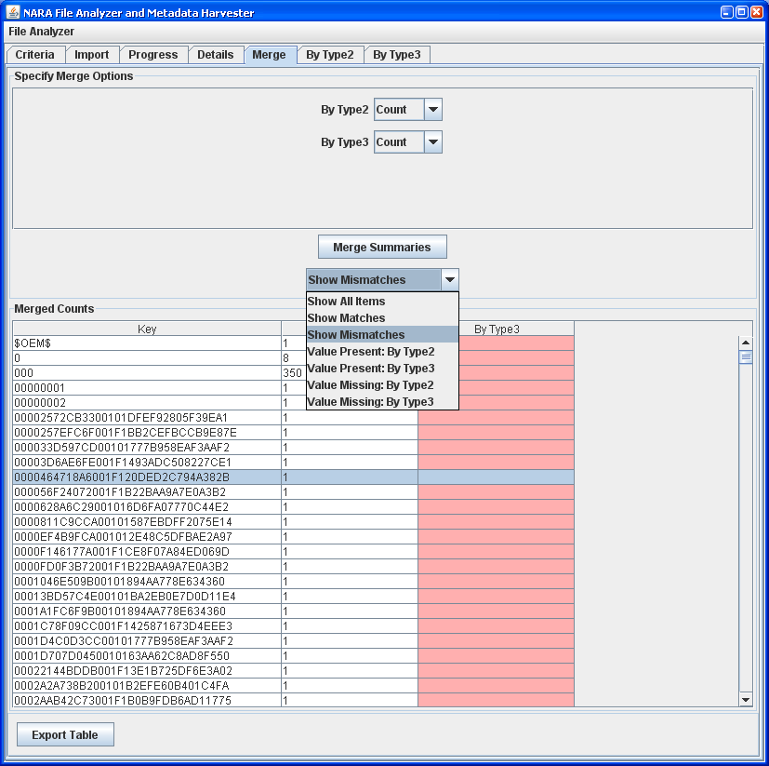
Power users of the File Analyzer can schedule a batch of similar tasks to be performed against multiple directories. Click “Enable Batch Processing” from the main menu to activate this feature.
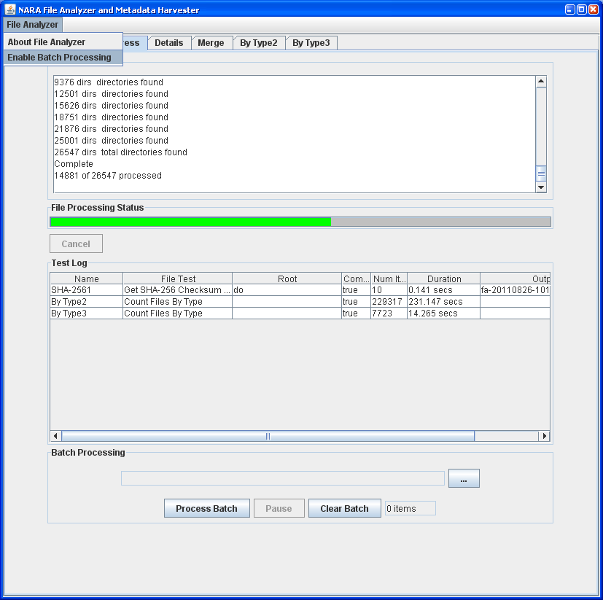
Load a “batch file”. This is a tab-separated 2 column file containing (1)the full path of the directory to process and (2) the name of the file to which results will be written write results. The File Test, Filters and Output Directory will be determined from the Criteria Tab.
In the following instance, you will see that directories related to 5 US states were processed. The results were saved to TXT files corresponding to each state's postal code.
Note: The batch processing feature is a bit confusing to new users of the File Analyzer. Take time to become familiar with the application before making use of this capability.

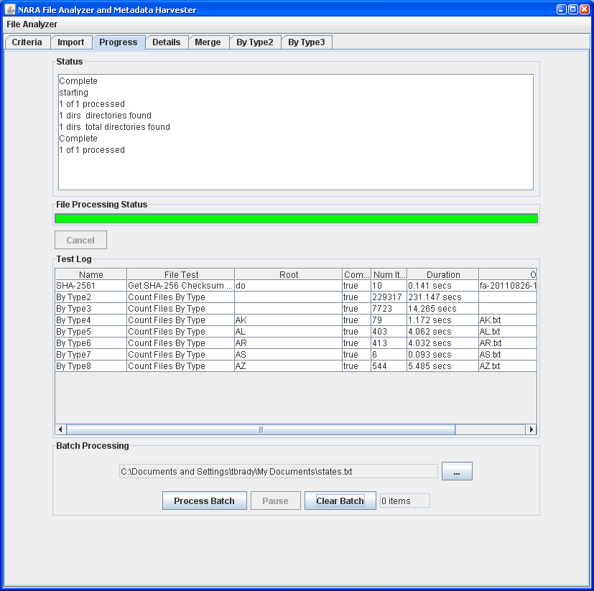
The file analyzer can be invoked from a command line.
java -classpath "fileAnalyzer.jar" gov.nara.nwts.ftapp.BatchAnalyzer -help
Usage:
BatchAnalyzer [-options] [-root rootdir] [-outfile outfile] filetest
to process a single directory, writing results to one file
If absent, rootdir will default to current directory.
If absent, outfile will be generated
or
BatchAnalyer [-options] -batchfile batch filetest
to process a collection of directories
The batch file is a tab separated file containing:
rootdir --> result filenames

where options include
-outdir <dir> Directory to which output files will be written.
Defaults to working directory
-max <num> defaults to 500000
-overwrite defaults to true
-listfilters lists the filters associated with a file test
-filter <name> name of the filter to use.
defaults to the first filter

the following options override filter defaults
-prefix <val> Filenames must start with this value
-suffix <val> Filenames must end with this value
-contains <val> Filenames must contain this value
-excludes <val> Filenames may not contain this value

result filtering options
-rf <col> <val> Only output results where column <col> matches <val>
Multiple rf vals may be provided
filetest
ByType Count Files By Type
DIR List Dir
Name Match By Name
BaseName Match By Base Name
MD5 Get MD5 Checksum By Name
SHA1 Get SHA1 Checksum By Name
SHA-256 Get SHA-256 Checksum By Name
ByMD5 By MD5 Checksum
Path Match By Path
TypeDir Count By Type and Dir
Random Random Sampling Mil 105E
Lowercase Lowercase Test

Press any key to continue . . .
The import function can also be invoked from the command line.
java -classpath "fileAnalyzer.jar" gov.nara.nwts.ftapp.BatchImporter -help

Usage:
BatchImporter [-options] -infile inputfile importer

where options include
-outdir Directory to which output files will be written.
Defaults to working directory
-outfile Output file name, defaults to a system generated name
-max defaults to 500000
-overwrite defaults to true

importer
TAB Import Tab-Separated File
CSV Import Comma-Separated File
SEMI Import Semicolon-Separated File
LIST File List Importer
Parse Parser

C:\Documents and Settings\tbrady\workspace\fileAnalyzer>pause
Press any key to continue . . .

The following information is embedded within the file.
